Module 5

Pay yourself first,
Keep, spend allocation

I don’t think I’ve told any of you what my objective is in presenting this course: It’s to support people to create and maintain financial prosperity easily and effortlessly; bottom line, create success stories.
And next, I want to thank those of you who took the survey and let me know what topics you wanted me to cover, what your biggest fears were regarding money and investing and what support structures were needed. I will contact each of you after the course is completed to be sure we covered exactly what you wanted and needed, or make sure you get it if it wasn’t covered in the course.
To review: In Module 1, we covered thinking from the details or the big picture; we covered the three areas we all operate from; thoughts, feelings or values, and how feelings run us most of the time. But tapping into our values can overcome the feelings that can get in the way of our financial success. And when we listen to familiar information are we making statements or asking questions? Like, “I’ve heard this before,” versus “How can I use this to improve my situation?”
In Module 2 we did a word exercise to measure your relationship to either poverty or prosperity thinking; we will discussed our belief systems about money based on messages we may have received when we were young; we did another exercise for couples to understand each other’s money values; you wrote a 5 year financial goal, from the future; and finally we covered the 6 areas of influence from the book Change Anything to build a support structure that you will use to guarantee your success in the achievement of your goals.
I recommended that you continue to re-read your 5 year goal to be sure it’s a fit for you and your values and suggested creating milestones from 1 day, 1 week to 1 month on your goal.
In Module 3 we covered the Debt Elimination and Memory Jogger forms and two of the powerful financial tools used by the wealthy; the Balance Sheet and the Income and Expense form. These are also the tools the wealthiest people in the world use, and I hope you saw you don’t need any financial background to complete these forms. These forms measure how you’re winning the financial game of life, and getting on track toward creating work as a choice instead of a requirement. We spoke about the difference between personal-use assets versus investable assets.
In module 4, I introduced the Spending Register and asked you to track your spending: You were to track things like meals out, entertainment, parking, auto expenses, like fuel or any repairs, clothing purchases for you or family members, office supplies or outside services, and so on. Again, you didn’t need to track one time payments like an auto lease or rent. And I provided a very effective script to easily get referral business.
Tell me what showed up from tracking your spending?
Who made at least three calls and used the referral script? What were the results?

The concepts we are covering and the tools I’ve provided are what the wealthiest people use to both create and maintain their wealth, and I used John D. Rockefeller as an example. These tools are what supported me to grow a multi-million dollar net worth while only earning about $60,000 per year.
In previous modules I’ve described that financial freedom is having work as a choice instead of a requirement, or money at work so you don’t have to work. This is the point in time where you don’t have to depend on anyone else for your income, and I expect you to be free from consumer bad debt. You might have lots of good debt, but you’ll be independent of a job, career, and even free of government support. You will have a level of income from your investments that will cover your standard of living. It could be as simple as covering your food, utilities, minimum taxes and housing expenses to entertainment, travel, and large contributions to the communities, organizations or charities of your choice.
Before we talk about different ways of saving and investing money, let’s discuss your money rules. These are the rules you’ve set up for yourself, either unconsciously or consciously. These are the rules that guide your financial decisions. They sound like the following: I want to spend all my money before I die; I want to invest for retirement or financial freedom instead of buying gadgets today; I won’t invest more than 20% of my income back into my business; at what price will I buy or sell a stock; what is the minimum return I will accept on an investment; I never invest in real estate, or stocks, or bonds; I will never loan money to a family member, and so on.
Here are some of mine: My children must become self-sufficient.
I will only pay for a portion of their college. They have to earn some of the money themselves.
I won’t make investments with anyone other than my wife.
I will purchase an apartment building at a break even as long as I can add substantial value. I will not buy a building when the sales ad says, “Pride of ownership.”
The improvements I make to an apartment need to be returned in 12 months from the increase in rent.
Diversification leads to mediocre returns.
I would rather walk than pay someone to park my car.
Money in the bank is only a temporary parking place.
So, let me hear from any of you what your money rules might be.

Let’s talk about the two ways of saving money; one method is what most people use who live from paycheck to paycheck, and the other is a powerful method used by the wealthy that has been working for 5000 years and will lead you to financial freedom.
The first way would be to pay all your expenses first, and then if there’s some money left over you save it. This is not a trick question:
What might be some good reasons for saving money? Obviously since we’ve been talking about financial independence this could be one reason. But what else?
You could save for the down payment on a home, or second home, or income property, a vacation, new car, more education for yourself or for children’s education, emergencies, opportunities, or starting a new business. There are lots of good reasons for saving money, and this first method is one way to do it. When there is money left over at the end of the month, if there is any, you set it aside in savings. In the book this is circle number 1.
The method used by the wealthy would be to save first, as in circle number 2 in the book. Save a percentage of your income before you pay your expenses like 10, 15 or maybe 20% of your income. This is what I did. This is what Jerry Buss did who purchased the Los Angeles Forum, the Lakers basketball team, Kings hockey team and the estate of Douglas Fairbanks, Jr. and Mary Pickford.
Circle #1
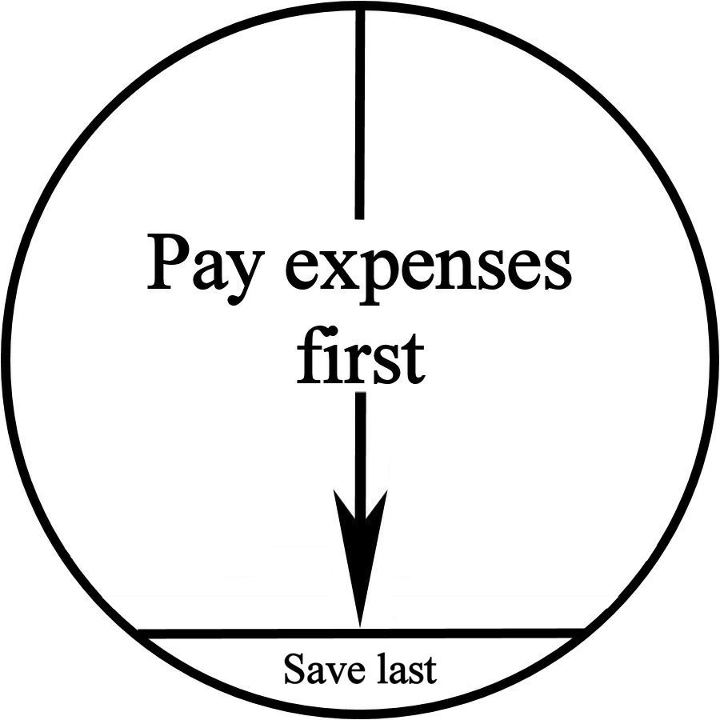
Right about here I usually get the question, “Should I be saving 10% of my income now, when I have all this debt I need to pay off?” My answer is yes and no. What I’m suggesting is you still must pay yourself first. It may not be 10%. Maybe it’ll be 4%, or $10 per week. But pay yourself something first. And you continue to make usual payments on your credit card debt. This will become very clear later on when I discuss the very high cost of waiting to invest.

Circle #2
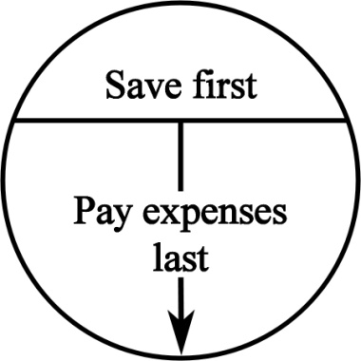I would like all of you to answer the following:
“Do you deserve to own, or keep, some of the money you’re earning?”
If you do, prove it! Pay yourself first. Pay yourself before you pay the telephone bill, the groceries, rent or transportation expenses. If you want to feel like you deserve to own some of the money you earn, you have to treat yourself like you do. And that means pay yourself first. You can’t wait until you feel like it first. When the action comes first, it will create the feeling.
After you’ve paid yourself first, then pay your expenses. And a part of the expenses will be your credit card or other debts. When they’re paid off, then you can dramatically increase the percentage with which you pay yourself first.
I worked with a psychologist many years ago, and she was resistant to do this. However, because she was paying me for my advice, she was willing to try it. What she found was that it not only worked, but her income increased. Why, because now she could see that the money wasn’t just flowing in one hand and out the other. She saw that was actually getting to keep some of the money she was earning.
Paying yourself first is not a new concept. The Richest Man in Babylon is a book written in 1936 based on some clay tablets found around the turn of the century. The tablets were between 3,000 and 5,000 years old from the city of Babylon, when it was one of the wealthiest city-states on earth. The tablets tell the story of a man who got into financial trouble in Babylon, fled the city, and decided to return and clean up his act. Across 5,000 years of time, the reader is exposed to how people were taught to handle money, the excuses they had, and what it took to create wealth. As you read history, you discover people have not changed materially in 5,000 years. And, the principles of creating wealth are the same today as they were 5,000 years ago.
Maybe you’re saying, “I can’t pay myself first and have the money I need to support my standard of living.” Here’s what I’ve seen: Someone pays all their bills one month, and among them is a phone bill for $100. At the end of the month there’s nothing left.
The next month they pay all their bills and among them is a phone bill for $150. Somehow they manage to pay the phone company an extra $50. I’ll venture to say that different things come up each month, and someone else gets more money from you than they did in a previous month, and you still end up with nothing at the end of the month. What’s missing here is putting yourself at the top of the list before the bills are paid. You’ll find some way to have nothing at the end of the month, but this time you will have some money for yourself. Again, this is how financial freedom is created.
One of my clients, an attorney, said he couldn’t possibly pay himself first. He told me he had $6,000 of bills to pay and had only received $5,500 of income. He said, “How can I pay myself first when I’m short $500 to pay the bills?” I find many people can relate to this, as it may have happened to them, or even be happening now. I suggested he set aside $250, or about 5%, of what came in. I showed him he now had only $5,250 to pay toward $6,000 of bills. He was now short $750 instead of $500, and I asked, “What difference does it make? You’re short either way. But now, you have $250 that belongs to you.”
He can look at that money and say he has something for the work he did. He’s not just a conduit for money to flow in one end and out the other, with nothing to show for it. Now he has something to show for it, even if it’s only $250. And psychologically, that $250 can spur him on to generate more income because now he sees he can have some of it for himself, instead of just paying bills with it.
One client, a business owner, said he did not deserve to own any of the money he was earning. He was in serious debt and even had a savings account seized for payroll taxes he owed. He said he owed too much money to others and therefore didn’t deserve to own any of the money he earned. It was that attitude which prevented him from generating more income to deal with his creditors and support his family. Again, there is a psychological shift that occurs when you treat yourself like you deserve to own some of the money you earn. It allows you to generate more money. You no longer see yourself as a pipe, with money flowing in one end and out the other. The feeling that ‘no matter how much comes in, you still won’t have anything’ will be eliminated when you pay yourself first.
How smart do you have to be to do this? If someone has an IQ of 70–80 they’re smart enough. One of the people in my workshop told me about her retarded cousin. Forget the politically correct terms. This is what the cousin said; his IQ was tested at 90. He was told when he was young he had to, as in no choice, put 25% of his paycheck into savings. Because of his low IQ he was only able to get minimum wage jobs. At the time the story was told to me in 1990, he was in his mid-30s and had accumulated over $90,000 in savings. Maybe you’re too smart and that’s why it won’t work. You can figure out clever reasons why you don’t have to do this. Sometimes we’re too smart for our own good. Her cousin was too stupid to do anything other than what he was told, so maybe stupidity helps.
In the city of Babylon 5,000 years ago, only 10% of the population had the discipline to pay themselves first and they created one of the wealthiest city-states in the ancient world. The United States is one of the wealthiest countries in the world today, and we have 10% of our population with the discipline to pay themselves first. Not much has changed in 5,000 years. For you to think you’ll be an exception to history is to court disaster. How about using what’s proven effective for 5,000 years?

Now, the question is where do you put the money when you paid yourself first? I prefer the simple savings allocation shown in shown in the book, and not the more sophisticated approach, also explained in the book.
Let me have each of you draw a circle and put a line through the middle of it.
In the top half of the circle put: Keep Forever, or Wealth Account, or Financial Freedom Account, whatever sounds good to you. Initially, 50% of what you set aside will go into this account. I’ll provide suggestions on where to invest this money in one of the next modules. This allocation I’m referring to often creates confusion, so I’m going to provide shocking simplicity.
In order to create financial freedom, and pay off past debts, and be prepared for future expenses, you must not only spend less than you earn today, you must set a portion aside for tomorrow. Working with thousands of people I’ve discovered the following: About 10–20% of what people earn needs to be set aside today to be spent later. When you add up non-monthly expenses like car repairs, registration, vacations, gifts, clothing and so on, the average is 10% of current earnings. If this is not set aside, then it won’t be available later, and this is how credit card debts are built up and kept. In the bottom half of the circle put “Spend Later.”
In addition, 10% needs to be set aside for your financial independence. This means, on average, 20-25% of what you earn today must be set aside for the future. 10-15% will be spent later, and 10% will be kept for the rest of your life. Again, this is your Wealth Account or your Financial Freedom Account. Simply put you keep this money forever and it’s used to buy the assets that will generate the income so you no longer have to work.
The top half of the circle would get 10% to create financial freedom and the bottom half of the circle would show 10-15%. So each time you receive money 20-25% needs to be set aside. Half goes to long-term savings and investments and about half is to spend later.
If all you can start with is to set aside 10% of your income, then 5% would go to long-term and 5% would go to spend later. While yours could be slightly different, like 40/60, I want to keep it simple, and any allocation is better than none at all.
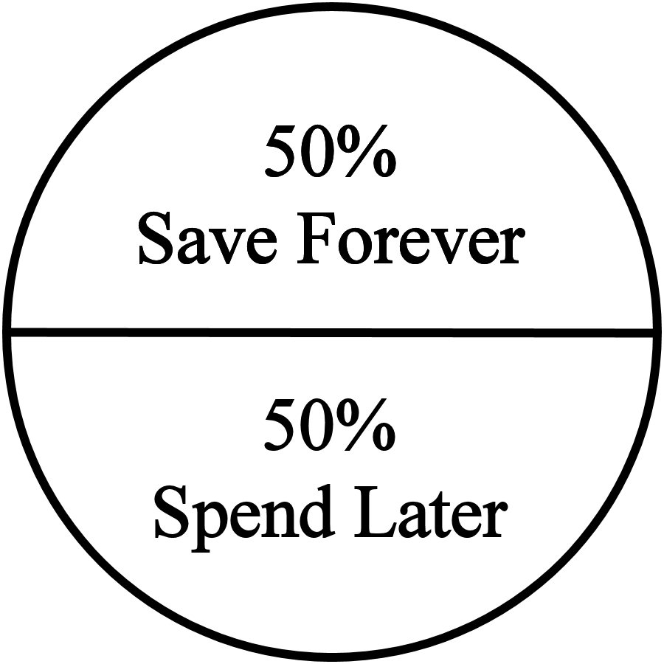

A. Simple savings allocation

When you go to the bank and ask what types of accounts they have, they’ll generally tell you they have two primary types of accounts: checking and saving. For most people this is not true. For most people the banks have checking and spending accounts. Most people who open up savings accounts only save up money until they have enough to buy some item they will consume. I don’t consider that a savings account, I say that’s a spending account. I’ll explain shortly that you will open an account like this, but it won’t be for long-term savings.
When I say savings, I mean save for the rest of your life, not save for a new car or vacation. I mean to save to create financial freedom. The money for a vacation or car goes into a spending account, which the bank calls a savings account.
We will go into far more detail on this in a later module, but what are some of the ways you could be paying yourself first and putting it away for long-term use? You could put it into a mutual fund by dollar-cost-averaging, a life insurance policy (whole life, universal or variable life), payroll deduction into a credit union or 401(k) plan, or automatic withdrawals for the down payment on your first or second piece of real estate. 50% of the money you pay yourself first will never leave your hands and go to someone else, like the grocer, utility, or clothing store. It will go into an investment that will be part of creating your financial freedom. Again, I’ll go into far more detail in the next module.
50% of the money goes into what the bank calls a savings account. You know this is a spending account. This money can be for an emergency or for emotional spending. This is where the money comes from which gets spent on things you’re rarely prepared for, like the car breaking down, or the water heater which needs to be replaced, back to school clothes, or the semi-annual insurance premium or property tax bill, or the unexpected medical expense.
Some of the money in this planned spending account can be for emotional purchases. Now you buy something and not feel guilty about it because you hadn’t planned on making the purchase. It could be for a weekend trip you need, just to get away. It could be to purchase a gift for someone, or even yourself. The money was there waiting, you just didn’t know what it was for when you put it away. Take out the money and buy what you want, and don’t feel guilty. Isn’t that a great way to buy something? This is the practice which will allow you to get away from using credit cards in an emergency. You now have cash to use.
A 50/50 or 40/60 split is a useful rule of thumb for the amount to go into the future spending account. If you remember from the previous module on the Cash Flow Form there were small stars (*) next to some items such as auto repairs, auto registration, clothing, vacations and others. This represents items most people don’t spend money on each month, but will spend money on during the course of a year.

If you have an accounting or engineering mindset, you can get more sophisticated by planning for annual, semi-annual, periodic or even sporadic expenses. Start by looking over all of the starred expense categories for items that do not occur each month, but can be broken down into a monthly amount such as property taxes, annual insurance premiums, auto maintenance, vacation, a major purchase, or school tuition. Now divide the annual amount by 12 and set that amount of money aside each month. There’s an example in the book on page 125.

Whether you elect to use the simple approach or the sophisticated approach, this is a crucial exercise. By seeing if you have the money to set aside for the items that don’t show up each month, you know if you are living beyond your income. And if you are, you’ll know by how much.
Personally, I used the more simplified approach to set aside 20% of my income. Each time I deposited money at the bank I transferred 20% into savings. It didn’t matter if I was standing in front of the ATM machine or the teller. I received checks for consultations, speaking engagements, book and cassette tape sales, and coaching fees. It didn’t matter where the money came from, how large or small the check, 20% was set aside in savings.
I think the story in the book on page 127 about the two attorneys and how tracking their spending helped turn around their financial life. I’m not going to spend the time on our call to tell you the story because you can just read that on your own.
What these two attorneys and I discovered is that when people handle expenses more responsibly they seem to generate more income easily and effortlessly.
I have two theories as to how this happens, and you can choose the one that is most comfortable for your belief structure.
First theory: When we have shown we can handle money more responsibly the universe aligns with who we’ve become and more money shows up. We generate money more easily and effortlessly. We see opportunities we would have missed in the past.
Second theory: By taking responsible actions, like paying ourselves first, paying bills on time, or living on less than we earn, we create a psychological shift. We now view ourselves differently. We’re proud of who we are. We now make even better choices and decisions. Others recognize this shift in our self image also. We now see opportunities we would have missed before and generate more income easily and effortlessly.
These results have been demonstrated in my life and the lives of my clients over and over again. I don’t care which theory you want to adopt, just adopt one of them. The results prove the actions work. You don’t need to understand how electricity works to turn on a switch and have a light come on. You only need to take the action of turning on the switch. You don’t need to know why or how paying yourself first will create more money, or how spending less that you earn will create more money. Just do it and you will have the rewards.

Please continue to track your spending.
And make another three calls using the referral script.
In our next module we will cover compound interest; stocks; bonds; mutual funds; peer to peer; TDs; and real estate investing. And we will talk about 2 different paths to financial freedom. One is slow and steady, and the other is geometric. After two divorces and starting over, I took the quantum physics approach and moved from broke to millionaire in 10 years. So that call will not be limited to putting $300 per month away into stocks or mutual funds. We will also talk about real estate and business building.

Are there any questions before we complete this call?

